Name:  Class: | ____________________________________  ________________  / 53  8% | Date:__________
 | Year 7 Mathematics  Angles, Triangles and Quadrilaterals
- Draw a line to match the words to the angles (not all the words will need to be used). [8 marks]
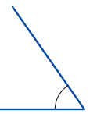
Vertically opposite
Straight
Reflex
Supplementary
Acute
Obtuse
Revolution
Corresponding
Co-interior
Alternate
Right

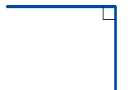

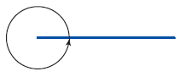
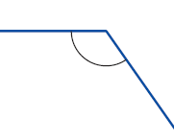


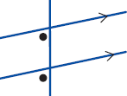

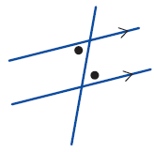
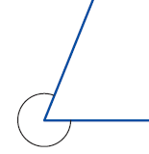

- Find the size of each of the following angles and use the letters to name the angles. [8 marks]
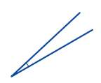
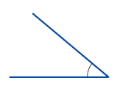
- b)
S
J
A

T
B
C

Name : ___________ Size:__________ Name : ___________ Size:__________
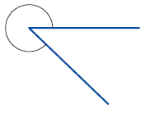
- d)
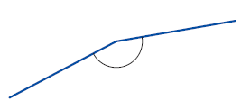
Y
X
U
F
T
L
Name : ___________ Size:__________ Name : ___________ Size:__________
- Draw the following angles [4 marks]
- 42º b) 167º

- Use your knowledge of angle relationships to find the unknown angles (DO NOT USE A PROTRACTOR). [8 marks]
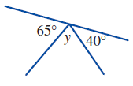
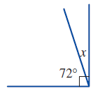
a) b)

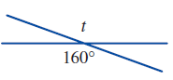
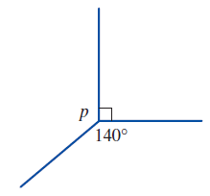
- d)

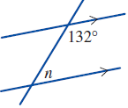
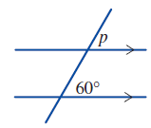
- f)

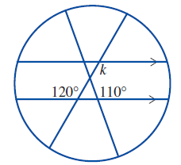
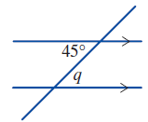
- h)

- Identify the following triangles using; [6 marks]
    - The lengths of their sides
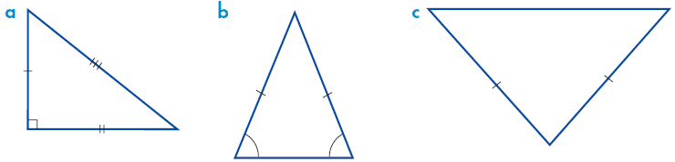
    - The size of their angles
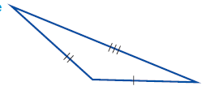

i)____________________

ii) ___________________
i)____________________

ii) ___________________
i)____________________

ii) ___________________

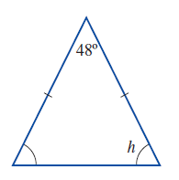
- Find the missing angles in the following shapes. [4 marks]
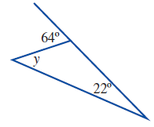
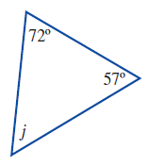

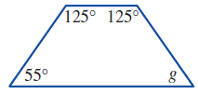

- Draw the following shapes. Include any notation required parallel lines, same length sides, right angles or use a symbol to show angles are the same size. [8 marks]

- Square b) rhombus c) trapezium d) kite

- Find the value of all unknown angles. [4 marks]
W =

X =

Y =

Z =
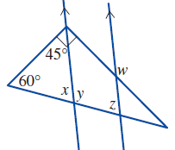

- Three students have measured the angle below. Mark thinks the angle is 140º, Dianne thinks it is 40º, and Marsha thinks it is 220º. [3 marks]
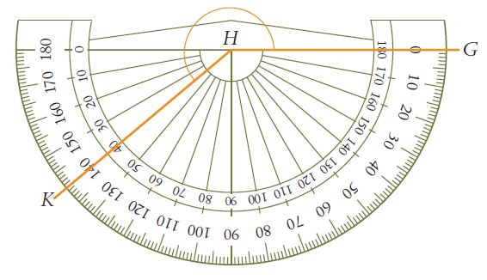
- Who is correct?

- What did the other 2 students do that was incorrect?

